In Minnesota, the number of Emergency Department (ED) visits for mental health in Minnesota have increased 75% from 2010-2017, while total ED visits increased 16.2% (Minnesota Hospital Association). Shared standards for addressing mental health crisis in EDs are not currently in existence and are critically needed, similar to healthcare standards for cardiac arrest or stroke.

The organizations in MN Health Collaborative, working together since 2017, are developing and implementing these standards to improve the ED experience, including transitions, for people with mental health needs and those who serve them.

Shared Standards for Care in Minnesota EDs
The MN Health Collaborative started by focusing on improving care within the walls of their EDs. A full package of shared standards is being developed including assessment, intervention and transitions. The Collaborative has already developed and committed to community-wide standards in two areas, implementing changes in their organizations in the following areas:

Medical Clearance Evaluation
Impact: Standardize best practice and reduce unnecessary labs and testing done when determining if an individual is medically stable to transfer to an inpatient facility. The group began with this shared area of focus in 2018 as a starting place with an additional aim to build better communication and trust between EDs and inpatient facilities, both intra-organizationally and across their health systems. This work is now being spread to other inpatient and ED facilities.
Learn more: Medical Clearance Evaluation in EDs for People With Mental Health Needs

Suicide Prevention and Intervention
Impact: Standardize evidence-based practices in screening, assessing, intervening, and conducting follow-up for people at risk of suicide presenting in EDs. The group developed and released these shared standards early in 2019. These recommendations provide practical guidance alongside CMS and new Joint Commission requirements as of July 2019. This effort supported organizational decision-making to improve policies, approaches with patients, and use of evidence-based tools. All organizations have now adopted the same screening tool, the Columbia Suicide Screening Severity Rating Scale (C-SSRS). Now, they are working to improve practices in assessment and intervention and doing early work to operationalize follow-up to reduce further suicide risk. This area of shared standards will be revised with more implementation guidance including trauma-informed culture based on input from people with lived experience and family.
Learn more: Shared Standards for Suicide Prevention and Intervention in EDs
Shared Standards in Process – Agitation and Aggression
In addition to the above, the group has begun work to develop shared standards for interventions for agitation and aggression. Other areas of shared standards will include further ways to advance active interventions, including while people are waiting for beds/services, discharge planning.

Improving Crisis Transitions with Community Partners
In Minnesota, other agencies and care providers are also highly interested in improving care and flow for people in crisis. 2020 begins an extended effort with cross-sector stakeholders to collectively coordinate efforts and align for impact.

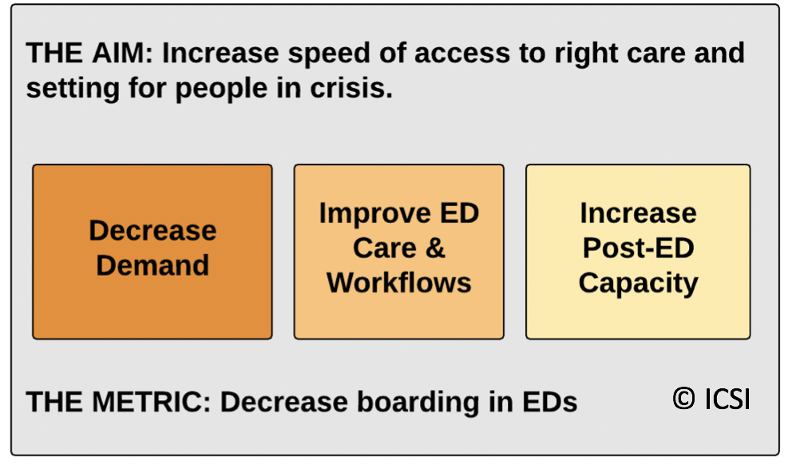
There is a need for shared understanding and action across sectors in order to address the needs and issues both locally and statewide.

In 2020 the MN Health Collaborative is hosting monthly virtual events to share the issues and spread solutions already occurring locally between EDs and other settings. This dissemination will be prioritized by data on reasons for prolonged length of stay. This way practical solutions can be spread while we also determine – as a statewide community – the macro changes needed.

Aligning in this effort include:

- Minnesota Association of Mental Health
Community Programs (MACMHP)
- Mental Health Providers Assoc.
of MN (MHPAM)
- Minnesota Hospital Association
- Minnesota Medical Association (MMA)
- Minnesota Psychiatric Society (MPS)
- Minnesota Association of Resources for
Recovery and Chemical Health (MARRCH)
- MN School Social Workers Association
- Mental Health Minnesota
- National Alliance on Mental Illness (NAMI)
- PrairieCare
- Department of Human Services, Direct Care & Treatment
- MN Health Collaborative Members
- ICSI Members
- Counties, Law enforcement, EMS, corrections, public health, others.

The MN Health Collaborative is an initiative driven by ICSI that brings healthcare organizations together to address major health topics, currently including opioid misuse and addiction, and system improvements for broader mental health care needs. The MN Health Collaborative consists of physicians and other representatives from: Allina Health, Blue Cross Blue Shield, CentraCare Health, Children’s Minnesota, Essentia Health, Fairview Health Services, Gillette Children’s Specialty Centers, HealthPartners, Hennepin Healthcare, Hutchinson Health, Medica, North Memorial Health, Ridgeview Medical Center, Sanford Health, UCare, UnitedHealthcare of MN, ND and SD, and University of Minnesota Health/University of Minnesota Physicians.

